1. Look at the pictures below. Tick all the things that use electricity.
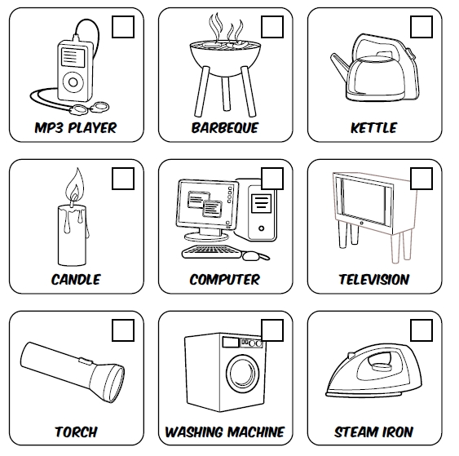

2. Why is mains electricity more dangerous than batteries?
________________________________________________________________________________________________________________________________________________________________________________________________________________________________________________________________________________________________________________

3. Why must you never have electrical appliances in the bathroom?
________________________________________________________________________________________________________________________________________________________________________________________________________________________________________________________________________________________________________________

4. Look at the dangerous pictures below. What is wrong? Why? Write your answers in the spaces below the pictures.

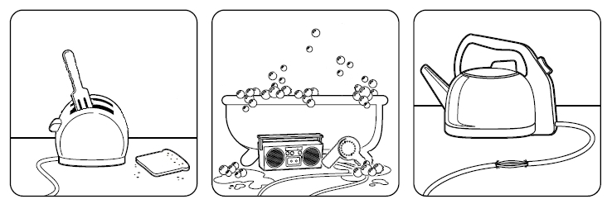

________________________________________________________________________________________________________________________________________________________________________________________________________________________________________________________________________________________________________________________________________________________________________

5. True or false?

Water conducts electricity True False
Electricity can jump True False
Electricity can severely burn or kill you if not used properly True False

6. Write 3 facts about batteries.
________________________________________________________________________________________________________________________________________________________________________________________________________________________________________________________________________________________________________________

7. Write 3 facts about electricity.
________________________________________________________________________________________________________________________________________________________________________________________________________________________________________________________________________________________________________________

